NAAN MUDHALVAN ASSIGNMENT
DIGITAL MARKETING

NAME: Dineshkrishna H
ROLL NO: 2020308007
DEPARTMENT: B.Tech Pharmaceutical Technology
COLLEGE: Alagappa college of technology, Anna University
ZONE: Zone-1

Assignment-1:
Create a company name and Design a poster and logo for that company.

Company Name: Last meal
Company Description: Restaurant
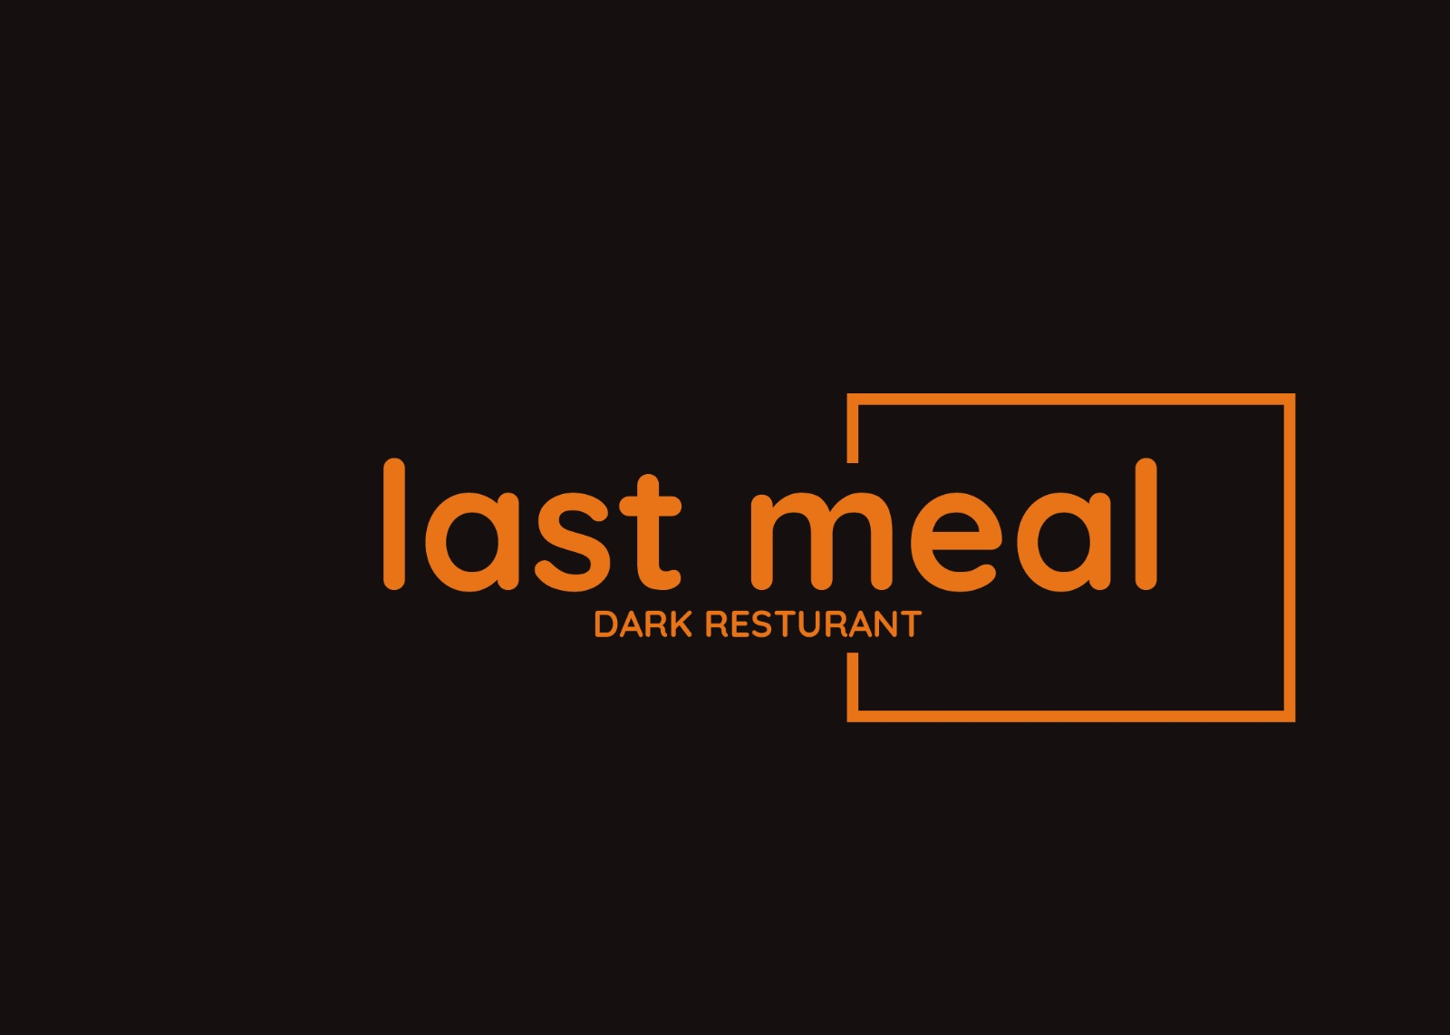
Logo:

Poster:
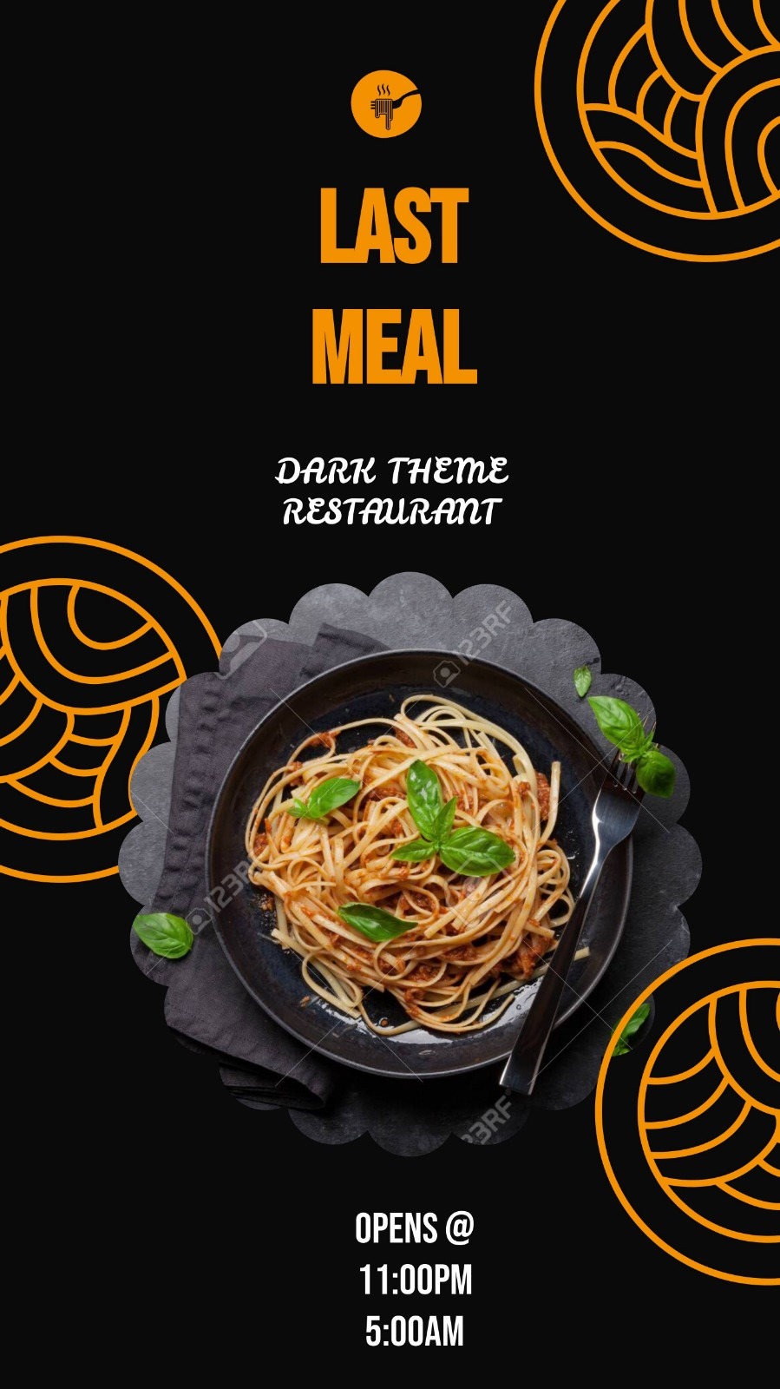

Assignment-2:
Create a blog describing about your company.

Blog Link: https://lastmealres.blogspot.com/2023/08/last-meal-exploring-enigmatic-allure-of.html
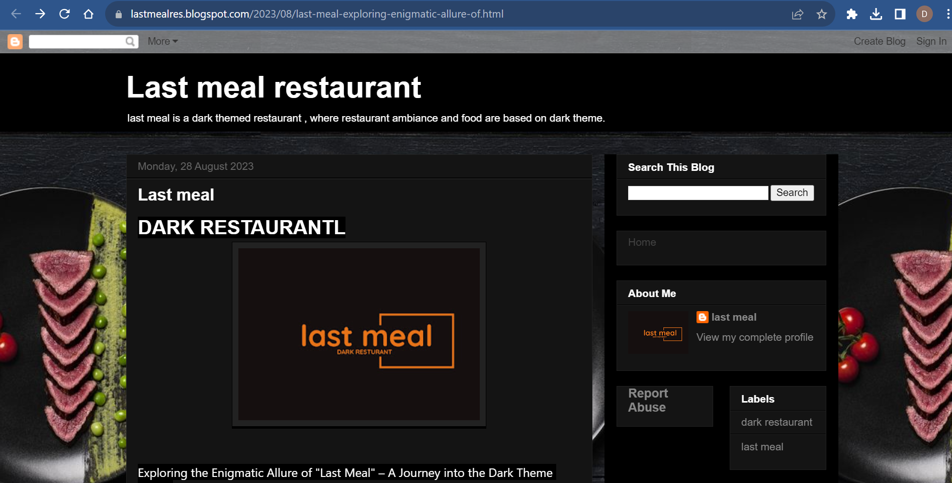

Assignment-3:

Create a Facebook account for your company

Facebook ID: https://www.facebook.com/plugins/post.php?href=https%3A%2F%2Fwww.facebook.com%2Fpermalink.php%3Fstory_fbid%3Dpfbid0JA7XEafVN4akomGo3srkKCLz3k16xnmANCWkpAuWfy5eyZkhc4FqDriNfDaUt46Fl%26id%3D61550537410586&show_text=true&width=500

Assignment-4:
Create an Email Newsletter for your company and post it in your company blog site. Do google analytics for you blog and send google analytics id.

Google Analytics ID: G-E1LC2HEX14

Email Newsletter link:
https://lastmealres.blogspot.com/2023/09/lastmeal.html

Email Newsletter:

